To: Clinically Responsive Service Providers (CRSPs) – Child SED / Child IDD
From: Cassandra Phipps (Director of Children’s Initiative)
CC: Melissa Moody (VP of Clinical Operations), Ebony Redding (Special Project Specialist)
Re: FY 24 – 25 MichiCANs Q & A Session Update
Date: June 4, 2024

In preparation for the MichiCANs Hard Launch effective 10/1/2024, the Children Initiatives Department hosted a MichiCANs Q&A Session on Thursday 5/23/24 from 10:00am –11:00am via Zoom. MichiCANs Hard Launch is applicable to both SED and IDD Children Providers services members ages 0 to 21st birthday.

Recording: The MichiCANs Q&A Session recording is available by accessing the link and passcode below:

https://dwihn-org.zoom.us/rec/share/pW-qhHyjuiTGozj_cXT02ORzxGZzMRVQrf0jm6y5mb2aQTV262RXTNLzxwzS8LFT.tRz-582mF4TQ_gyb

Passcode: x3=d!&gy

MichiCANs Training: Clinicians, Wrap Around Facilitators, and Supervisors are also to register for the MichiCANs Training scheduled for June 2024 and July 2024 via the TCOM website: TCOMTraining.com

MichiCANs Documents: MichiCANs information and supporting documents are now available on the DWIHN website / Provider page: https://www.dwihn.org/for-providers

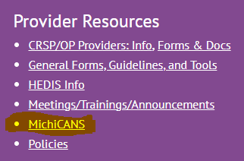
If you have any questions you can contact Cassandra Phipps, Director of Children’s Initiative @ cphipps@dwhin.org and Ebony Redding @ eredding@dwihn.org .

Sincerely,

Cassandra Phipps LPC, LLP, CAADC
Cassandra Phipps, LPC, LLP, CAADC
Director of Children’s Initiatives
Detroit Wayne Integrated Health Network

